Bill Calculator

A Grocery Shop requires an application for Bill Calculation. The person generating the bill is supposed to enter the product details in the form. On submitting the form, the total price is displayed.
Concepts covered: Web Forms 2.0 – input tag, placeholder attribute and required attribute
The following are the screenshots of the Bill Calculator
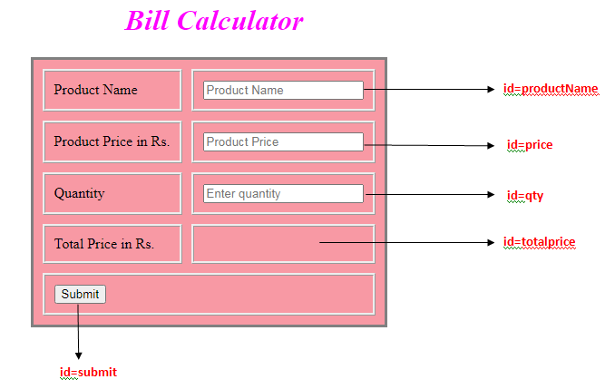

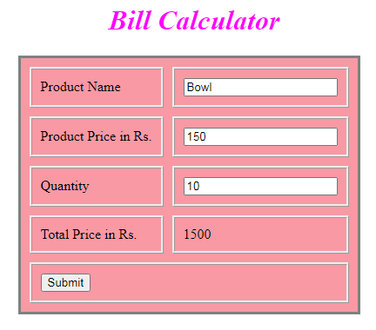
Use the Label Name and the Component Id as given. The Component Id can be given in any case (Upper case or Lower case or Mixed case).All the necessary attributes for the Components should be given. The Component Id should be specified for each HTML Component. If the Component Id is not provided for an HTML component, marks will not be provided for that component. All Tags, Elements and Attributes should conform to HTML5 Standards.
Provide the details as given in the table below.
Req. # | Req. Name | Req. Description
1 | Design a Web page “Bill Calculator” with the specified fields. | Label Name Component Id (Specify it for the “name” attribute) Description  Product Name productName To enter the product name. Design Constraints: Use type=”text”. The text “Product Name” should appear by default. It is mandatory.  Product Price in Rs. price To enter the price of the product. Design Constraints: Use type=”number”. The text “Product Price” should appear by default. It is mandatory.  Quantity qty To enter the product quantity. Design Constraints: Use type=”number”. The text “Enter quantity” should appear by default. Assume that the min value is “1”. It is mandatory.  Total Price in Rs. totalprice To display the total price of the product. Design Constraints: Use <p> tag. It is mandatory.  Submit button The input type button must be used.  NOTE: The text highlighted in bold in the Description needs to be implemented in the code to complete the web page design.

